# CS103 – Portfolio Project

## Think of an Idea

### What do I want to create recommendations for?

* ~~Wellington Restaurants~~
* ~~DnD Character Races~~
* ~~Recipe Recommendation~~
* Wellington Brunch Spots

### Who do you want to build something for? Yourself? Your friends? Your family? Your co-workers?

* Friends and Family

### What topics will be searchable in your recommendation system?

* Restaurant Name
* Suburb
* Meal with a view
* Now or another time

## Project Brainstorming

### What does your program do?

* Take input(s)
* Filter by:
  + Open Now
  + In a suburb or surrounding suburb
  + With a view
  + Details of a specific Restaurant

### What data do you need?

* Restaurant
  + Name
  + Address
  + Opening Hours
  + Nice View Boolean
    - Descriptor: Beach, Garden, Park
* Suburbs
  + Graph of which suburbs are adjacent to which

### What questions will you ask the user?

* Flow Chart Below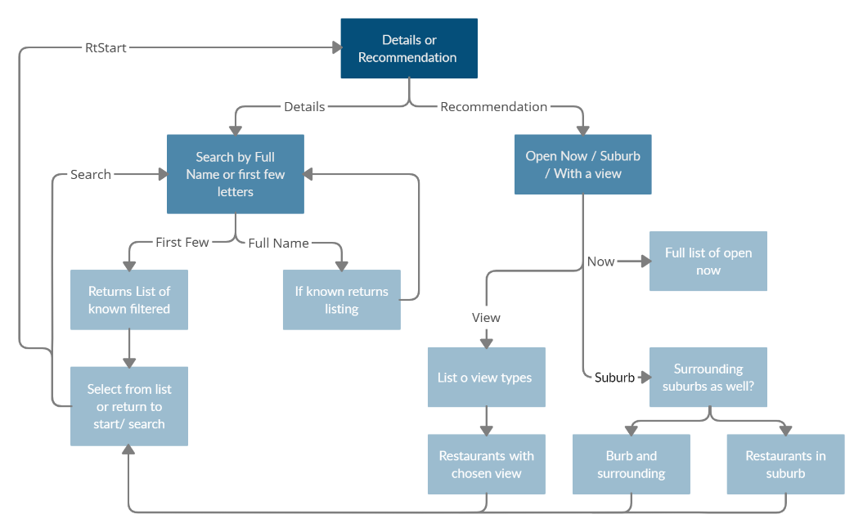

### How do the above questions return a recommendation?

* They take user preferences and apply them to filter down the full list to a smaller subset of restaurants that may interest the user